**VODAFONE session 1**

array3 = np.vstack([array1,array2])

print(array3.shape)

number of columns should be the same in order to make vertical stack

number of rows should be the same in order to make horizontal stack

list_1 = [i for i in range(10000)]

list_2 = [j**2 for j in range(10000)]

print(list_1[10:20])

print(list_2[0:10])

x

print(len(list1))

import time

t0=time.time()

product_list = list(map(lambda x,y: x*y, list_1,list_2))

#lambda function reduce the number of lines of code when compared to normal python function defined using def keyword

#they are generally used when a function is needed temporarily for a short period of time, often to be used inside

#using lambda function, you can define a function and call it immediately at the end of definition

#map is an anonymous function where it performs element wise operations over pair of collection objects

t1 = time.time()

list_time = t1-t0

print(list_time)

import numpy as np

ar1 = np.array(list_1)

ar2 = np.array(list_2)

t0 = time.time()

ar3 = ar1*ar2

t1=time.time()

numpy_time=t1-t0

print(numpy_time)

import numpy as np

import pandas as pd

——————————————

import numpy as np

import pandas as pd

data = pd.read_csv(“car_data.csv”)

data.head()

data.tail()

[data.info](http://data.info)()

data.describe()

print(data.car_name.value_counts())

#accessing data

data[0:10]

data[0:10,:]

#loc - label based, bloc - index based

data.iloc[0:10,:]

#returns first 10 entries

data.iloc[0:10,0:4]

#returns first 10 entries of first 4 columns

**VODAFONE session 2**

Introduction to machine learning and its types

Day 1

Data science lifecycle

Numpy

Matplotlib

Pandas

Day 2

Python - > scikit learn

how can this library be used to create ML models?

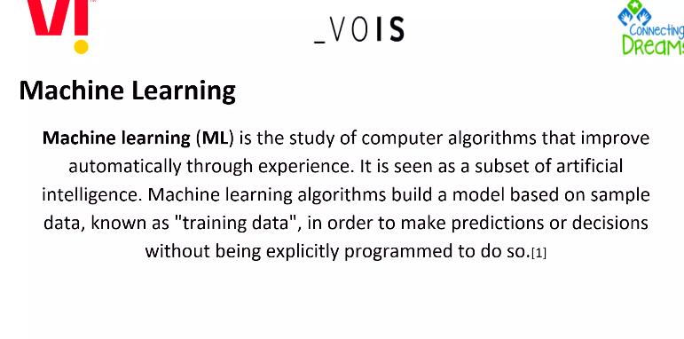

teach a machine about a specific data so that it can find out the insights and patterns hidden in the data

endgoal -> implement artificial intelligence

Input - Feature

Output - Label or Target

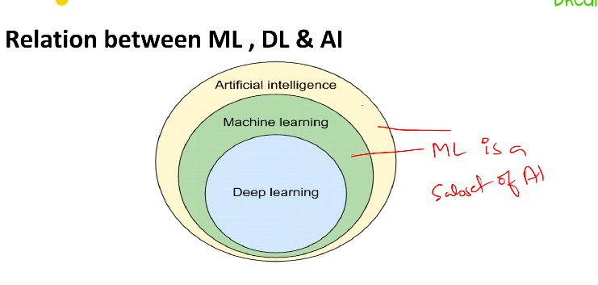

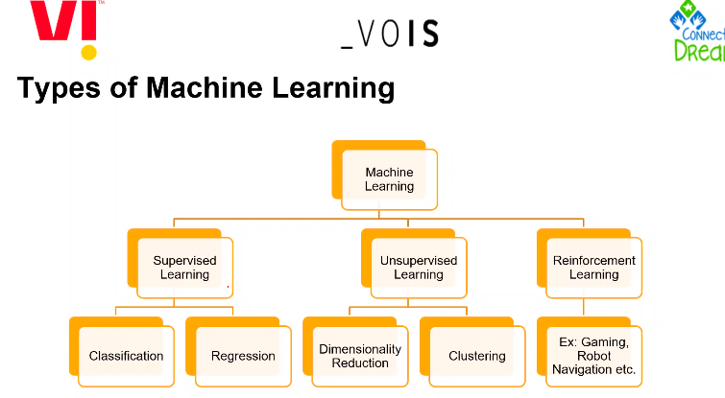

There is semi-supervised learning also

supervised learning

* output and input are explicitly mentioned

unsupervised learning

* only input is explicitly mentioned

reinforcement learning

* feedback

Integers are discrete

Real numbers are continuous

Classification

* output is discrete

Types of classification algorithms

1. K-nearest neighbour
2. Decision tree
3. Random forest
4. XGBoost
5. SGD classification
6. Support Vector Machine

Regression

* output is continuous

predict if a person has heart disease or not - classification

predict temperature of a city - regression

teachablemachine.withgoogle.com

underfitting

overfitting

Dimensionality reduction

Clustering